**Object Oriented Programming**

**23CSE111**



**Department of Computer Science and Engineering**

**Amrita School of Engineering**

**Amrita Vishwa Vidyapeetham, Amaravati Campus**

**Verified by: Name:**

**Roll number :AV.SC.U4CSE24040**

|  |  |  |  |  |
| --- | --- | --- | --- | --- |
| Week | Questions | Page No | Date | Sign |
| 1 | i. Download and install Java software  ii. Write a java program to print the message welcome to java programming  iii. Write a java program to print the name, roll no and section of the student |  |  |  |
| 2 | i. To calculate the area of the rectangle  ii. Program to convert the temperature in celsius to Fahrenheit.  iii. Program to calculate the simple interest.  iv. Program to find the largest of three numbers using the ternary operators.  v. Program to find the factorial of the number. |  |  |  |
| 3 | i. Create the java program for the cars with constructor and methods.  ii. Create the java program to withdraw and deposit money in the bank account. |  |  |  |
| 4 | i. Create the java program for the books by using the constructor and display its details using methods.  ii. Program to explain the final and the static variables. |  |  |  |
| 5 | i. Create the java program for the calculator.  ii. |  |  |  |
|  |  |  |  |  |
|  |  |  |  |  |

**Week-1:**

**Aim:** Download and install Java software

**Procedure:**

Step-1: Open any browser and search java download. Then open oracle website.

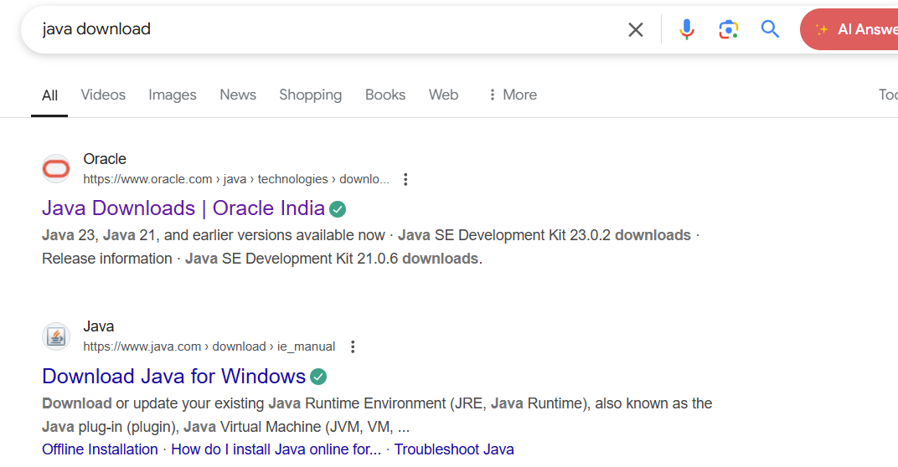

Step-2:It shows different java versions. In it download LTS version of your operating system. Download exe file

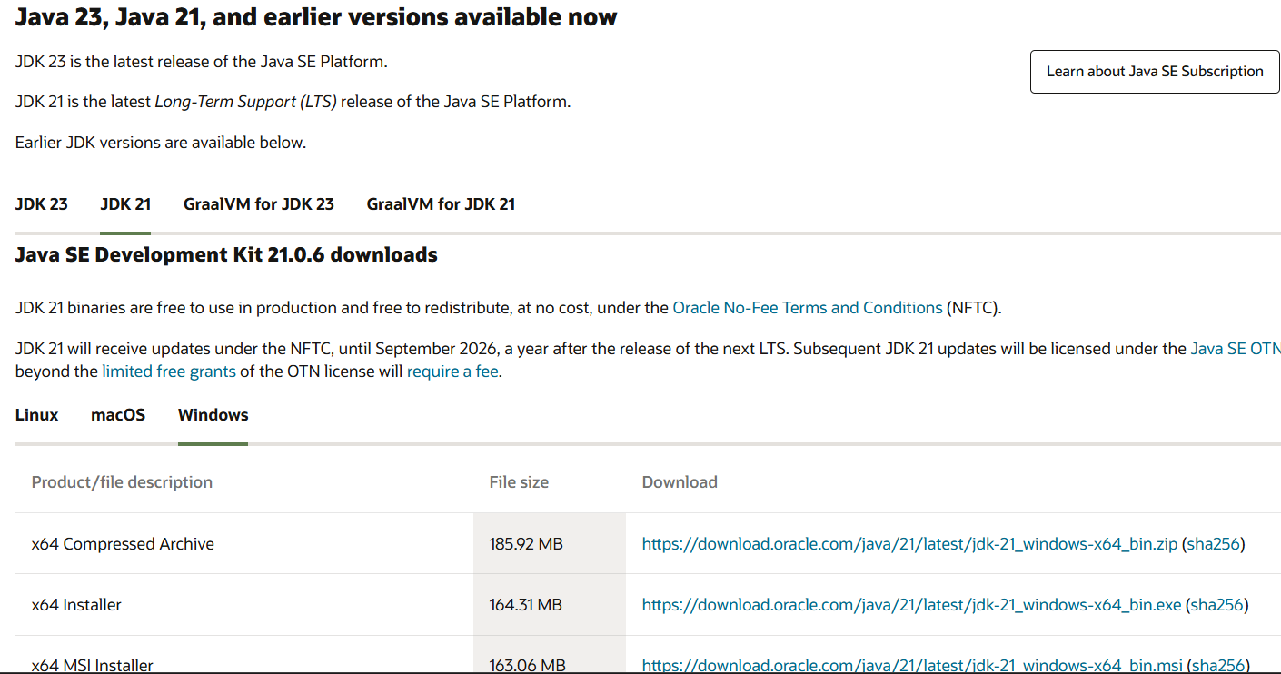

Step-3: Then open the downloaded file and allow all permissions and install it in the system.

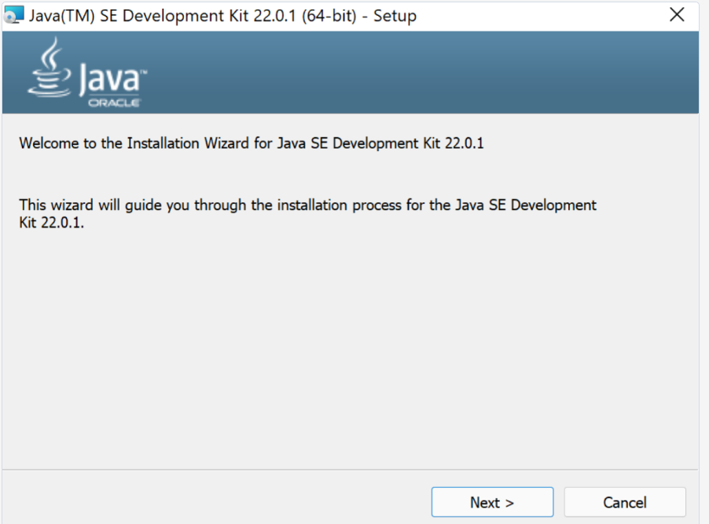

Step-4: Then open the files and go to the drive and enter into the program files.

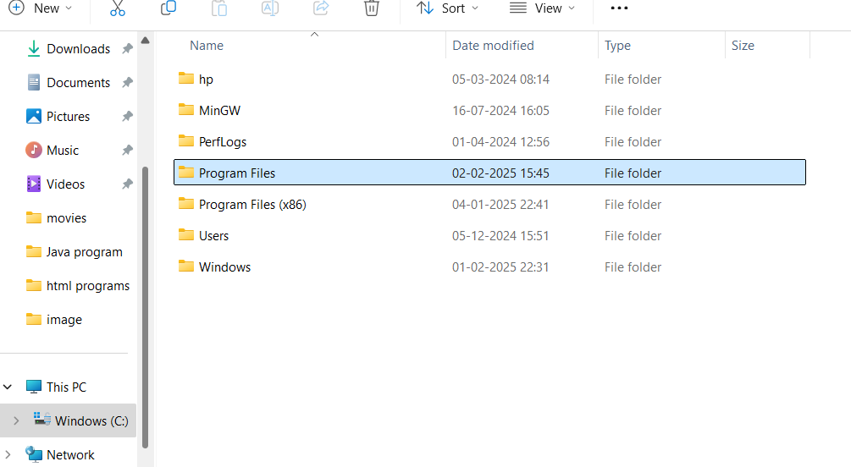

Step-5: Then open the program files and enter into the java, then open the jdk 21.

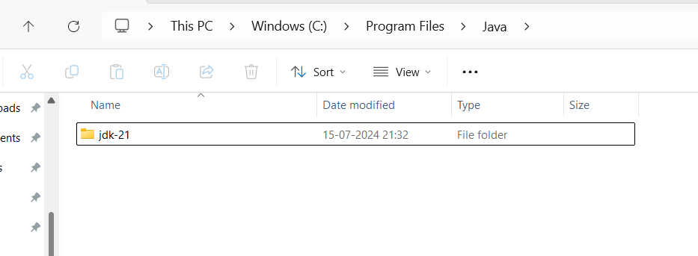

Step-6: Then enter into the bin. Then click on the on the bar to copy the path.

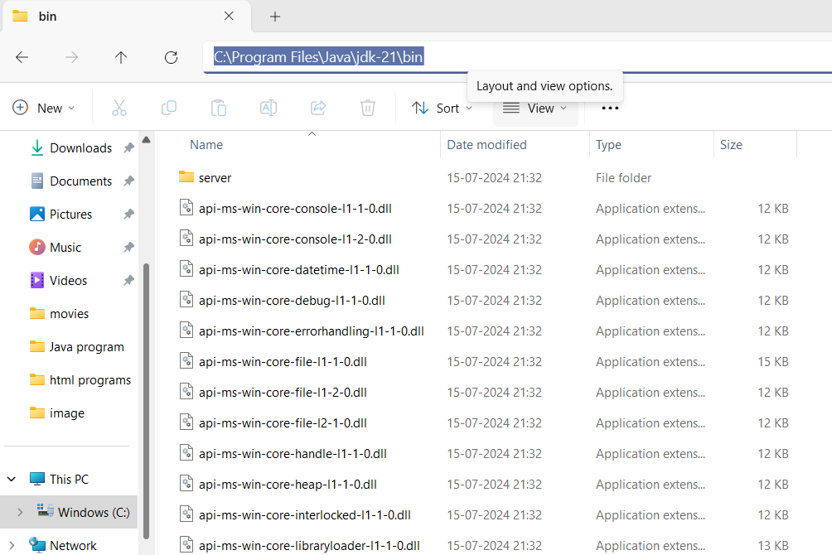

Step-7: Then right click on this PC and enter the properties, click on the advanced system settings, click on the environmental variables.

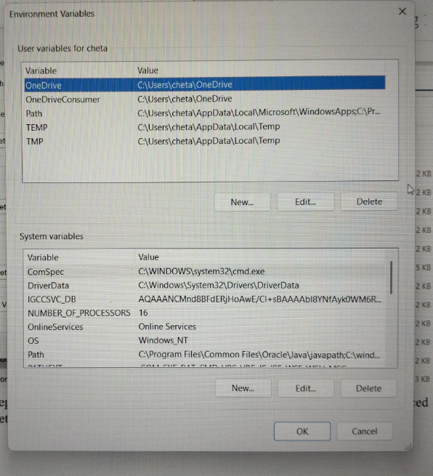

Step-8: Click on the new and paste the path and apply it. Then open the command prompt the enter java --version.

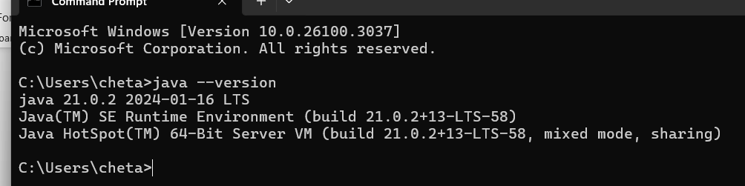

Hence java is installed.

**Aim:** Write a java program to print the message welcome to java programming

**Procedure:**

Step-1: To perform the first program open the new file in notepad and save it with name of the and .html.

Step 2: Write the program to print “Welcome to Java programming”.

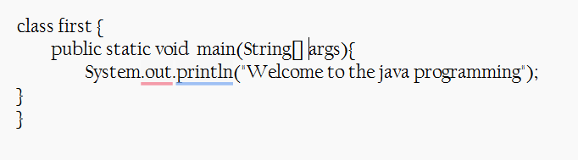

Step-3: Open the file in the files and delete the path and type cmd. Then type javac name.java and type java first. Then we get the output.

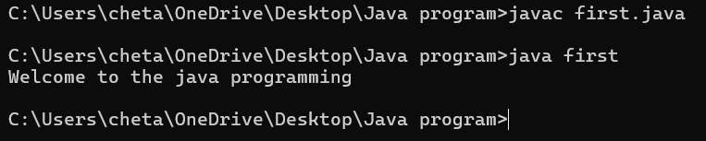

|  |  |  |
| --- | --- | --- |
| **Error Type** | **Description** | **Correction** |
| **Identifiers Error** | Forgot to write the main method | Ensure public static void main(String[] args) { ... } is present |
| **Syntax Error** | Used s instead of S in Scanner | Use uppercase S → Scanner scanner = new Scanner(System.in); |

**Aim:** Write a java program to print the name, roll no and section of the student

**Procedure:**

Step-1: Open the new file the save it and declare the varibles as per its date type.

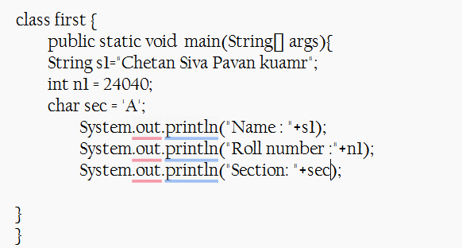

Step-2: Save it and run it using the command prompt.

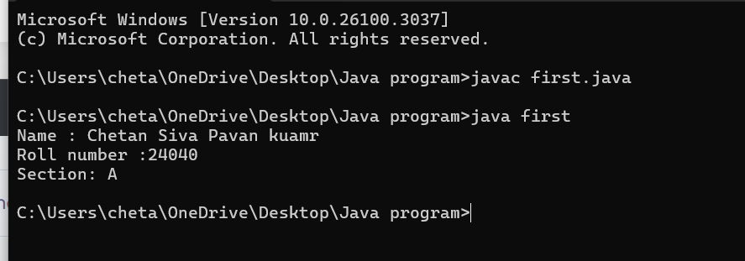

|  |  |  |
| --- | --- | --- |
| **Error Type** | **Description** | **Correction** |
| **Syntax Error** | Forgot to write ; (semicolon) | Ensure every statement ends with a semicolon (;) |
| **Variable Declaration Error** | Wrong variable declaration | Use correct data types and proper syntax |

**Week-2:**

**Aim:** Program to calculate the area of the rectangle.

**Procedure:**

Code:

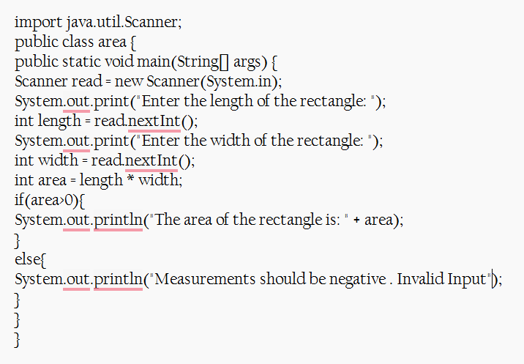

Output:

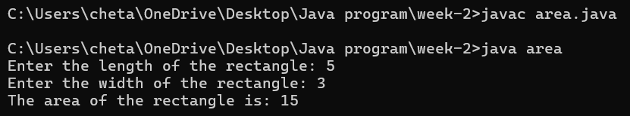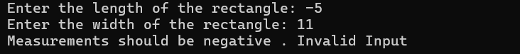

Errors:

|  |  |  |
| --- | --- | --- |
| **Error Type** | **Description** | **Correction** |
| **Syntax Error** | Unclosed string literal(“ missing) | Ensure all strings are properly enclosed in double quotes (") |
| **Runtime Error** | Dividing by zero when calculating an aspect ratio | Check for zero before division (if (width != 0) { ... }) |

**Aim:** Program to convert the temperature in celsius to Fahrenheit.

**Procedure:**

Code:

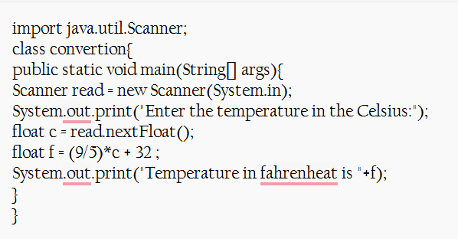

Output: 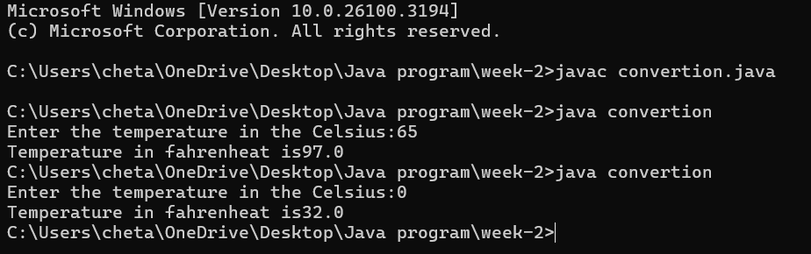

Error:

|  |  |  |
| --- | --- | --- |
| **Error Type** | **Description** | **Correction** |
| **Syntax Error** | Forgot to write ; (semicolon) | Ensure every statement ends with a semicolon (;) |
| **Runtime Error** | Dividing by zero when calculating an aspect ratio | Check for zero before division (if (width != 0) { ... }) |
| **Variable Declaration Error** | Wrong variable declaration | Use correct data types and proper syntax |

**Aim:** The program will calculate the simple interest.

**Procedure:**

Code:

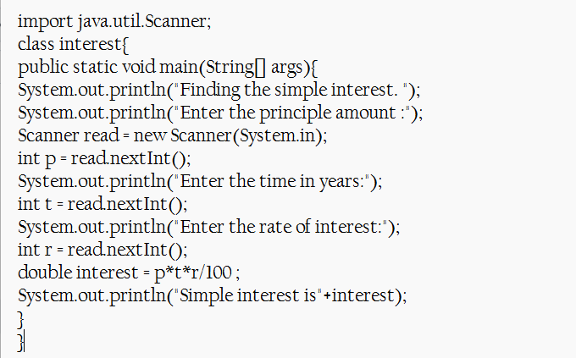

Output:

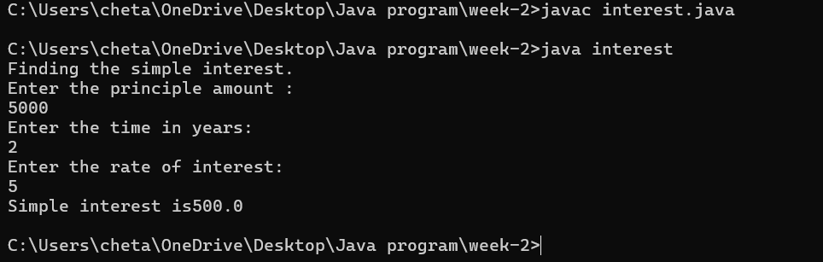

Error:

|  |  |  |  |  |  |
| --- | --- | --- | --- | --- | --- |
|  | |  | |  | |
|  | |  | |  | |
|  | |  | |  | |
| **Error Type** | **Description** | | **Correction** | |
| **Syntax Error** | Missing semicolon (;) after System.out.println() | | Add ; at the end of System.out.println() statements | |
| **Data Type Error** | int used instead of double for time (t) | | Change int t = read.nextInt(); to double t = read.nextDouble(); | |
| **Type Mismatch** | int r = read.nextDouble(); (assigning double to int) | | Change int r to double r for correct data type | |

**Aim:** Program to find the largest of three numbers using the ternary operators.

**Procedure:**

Code:

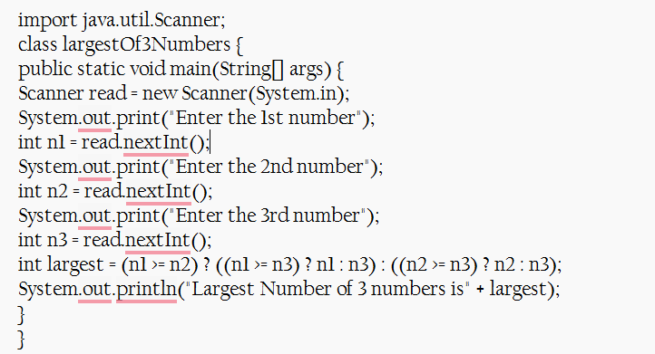

Output:

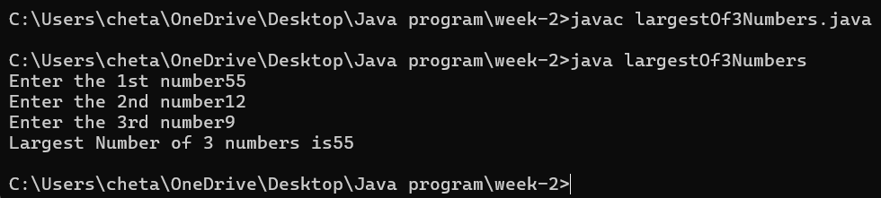

Error:

|  |  |  |
| --- | --- | --- |
| **Error Type** | **Description** | **Correction** |
| **Syntax Error** | Missing space in output: "Largest Number of 3 numbers is" + largest | Change to "Largest Number of 3 numbers is " + largest (add space before largest) |
| **Logical Error** | No read.close(); to free resources | Add read.close(); at the end of the program |
| **Input Handling Issue** | No prompt for invalid input (e.g., non-integer values) | Add input validation using if (read.hasNextInt()) before reading values |

**Aim:** Program to find the factorial of the number.

**Program:**

Code:

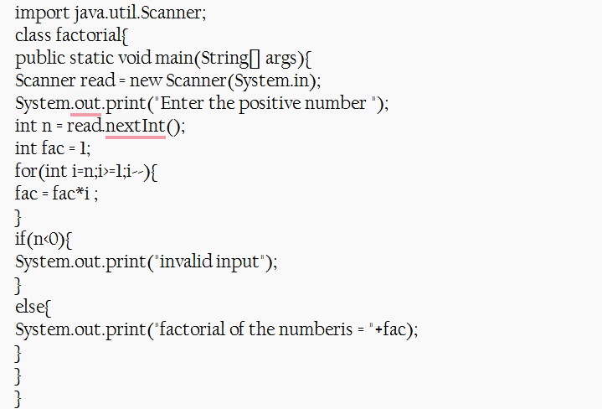

Output:

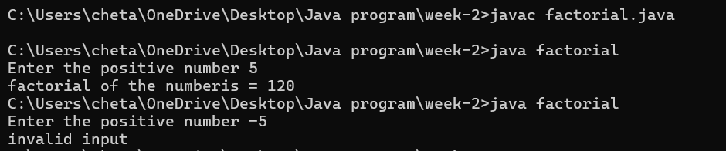

Error:

|  |  |  |
| --- | --- | --- |
| **Error Type** | **Description** | **Correction** |
| **Syntax Error** | do keyword mistakenly placed before for loop | Remove do before for(int i=n; i>=1; i--) |
| **Logical Error** | if(n<0) check comes after the factorial calculation | Move if(n<0) check before the loop to prevent calculation |
| **Resource Leak** | Scanner not closed | Add read.close(); at the end of the program |

**Week-3:**

**Aim: (i)** Create the java program for the cars with constructor and methods.

**Class Diagram:**

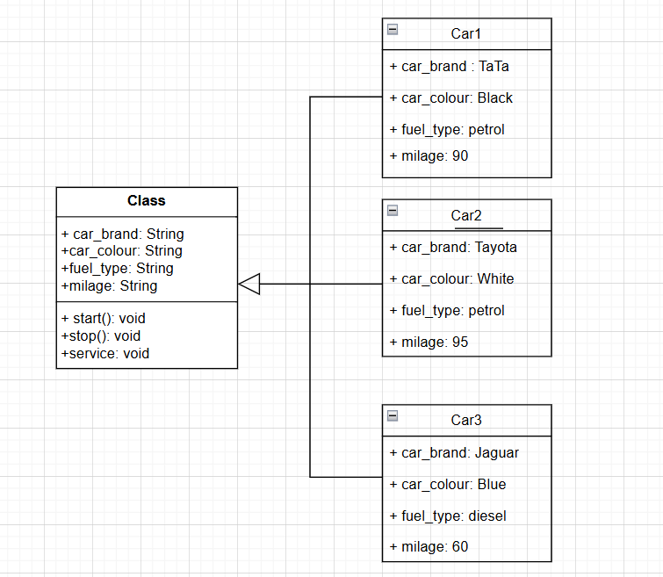

**Program:**

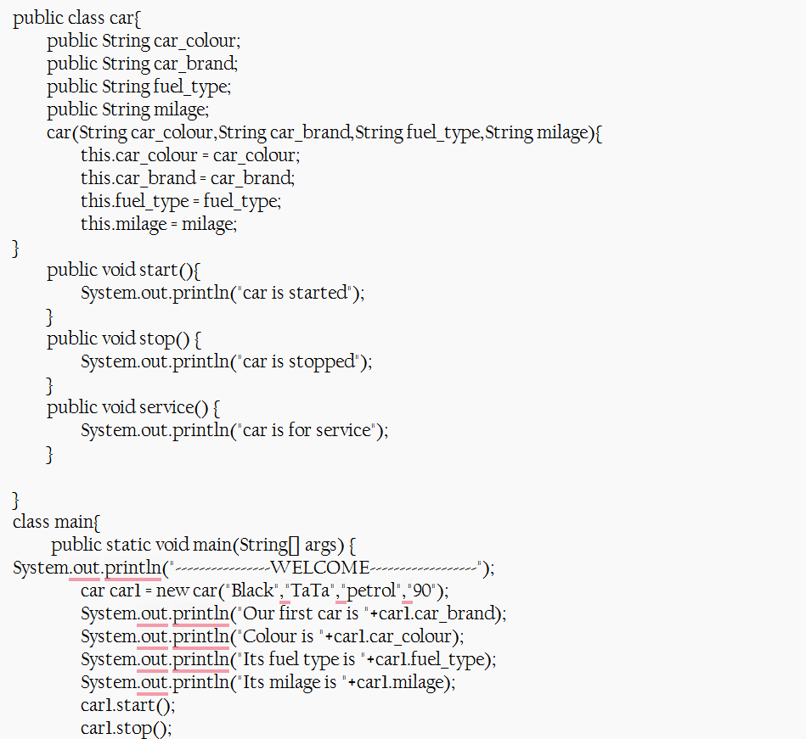

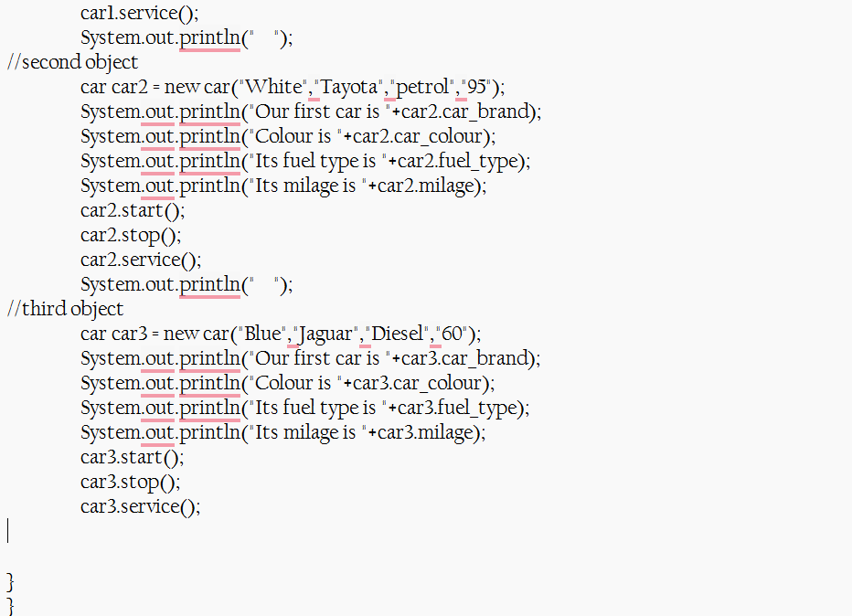

**Output:**

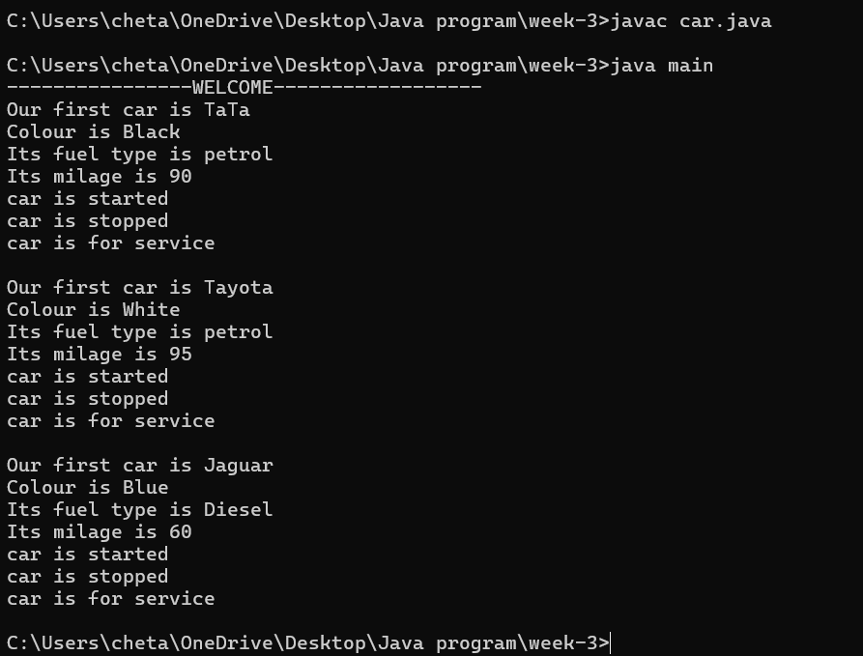

**Error:**

|  |  |  |
| --- | --- | --- |
| **Error Type** | **Incorrect Code** | **Corrected Code** |
| **Class Naming Issue** | class main{ | class Main{ |
| **Incorrect Object Description** | "Our first car is "+car2.car_brand; | "Our second car is "+car2.car_brand; |

**Aim: (ii)** Create the java program to withdraw and deposit money in the bank account.

**Class Diagram:**

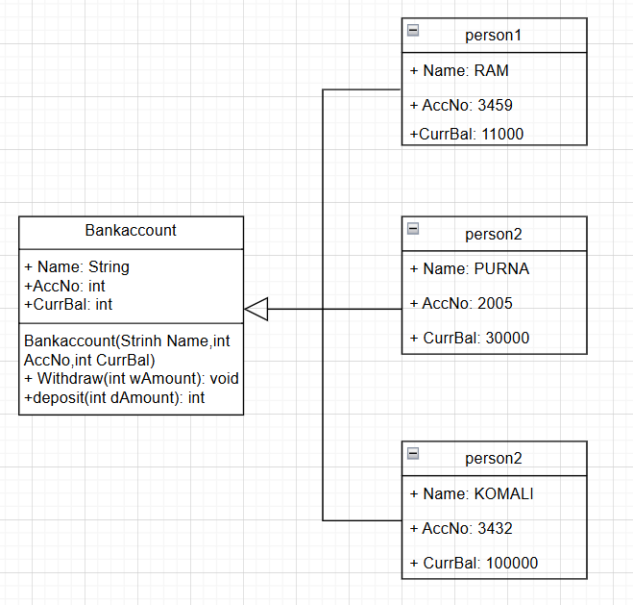

**Procedure:**

Code:

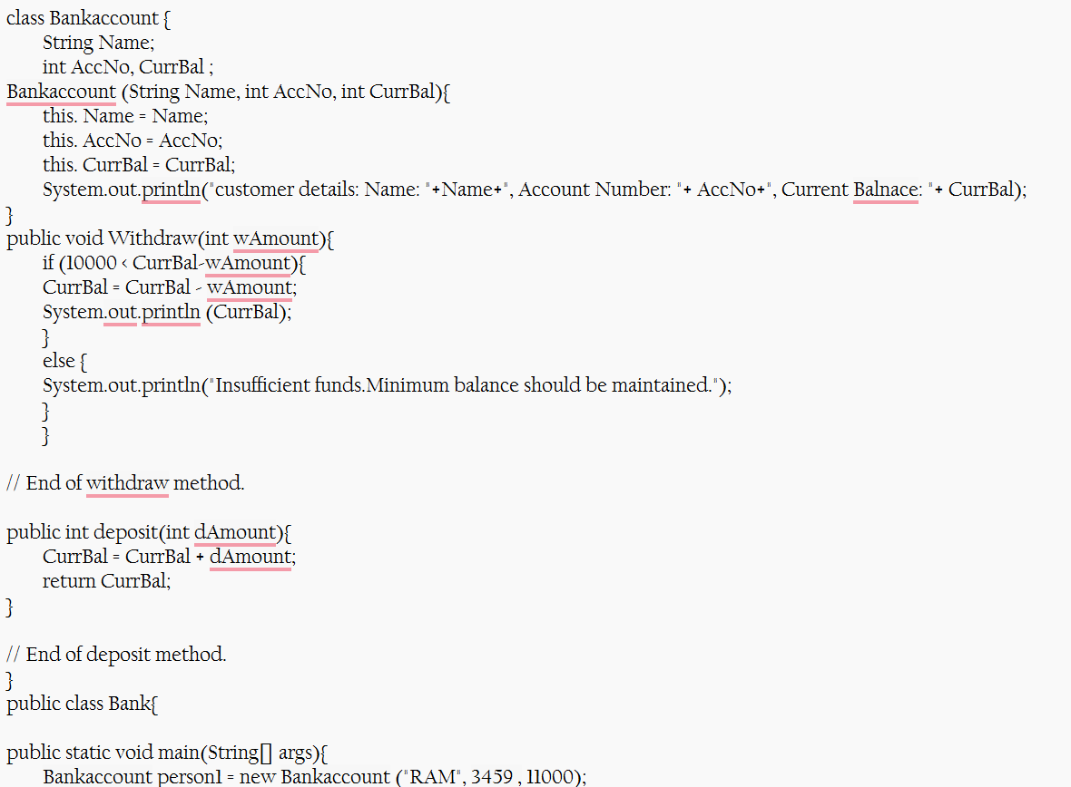

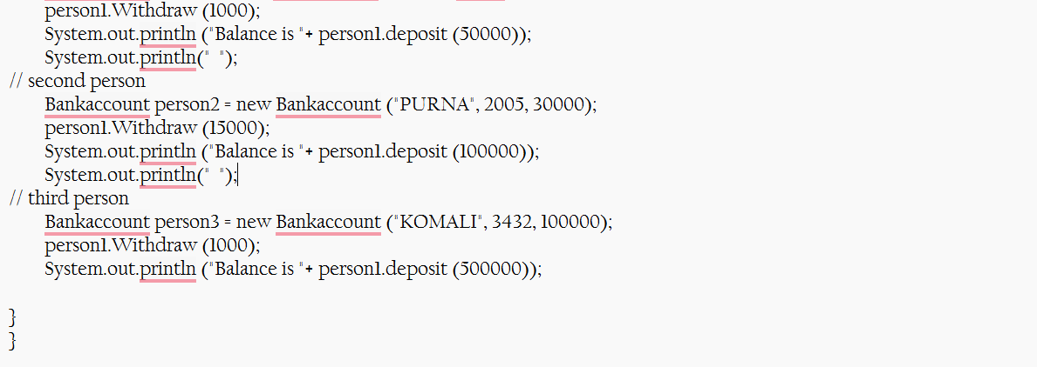

**Output:**

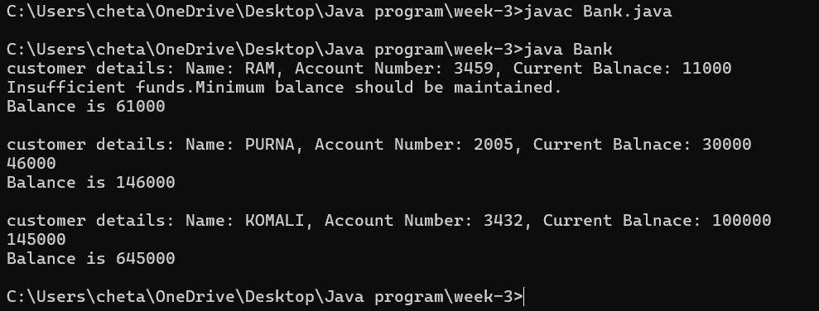

**Error:**

|  |  |  |
| --- | --- | --- |
| **Error Type** | **Incorrect Code** | **Corrected code** |
| **Class Name Capitalization** | class Bankaccount | class BankAccount (Java follows PascalCase for class names) |
| **Object Naming Issue** | BankAccount person-1 (hyphen is not allowed) | BankAccount person1 |
| **Missing Semicolon** | System.out.println ("Balance is "+ person-1.deposit (50,000)) | System.out.println ("Balance is "+ person1.deposit (50000)); (semicolon added) |

|  |  |  |
| --- | --- | --- |
|  |  |  |
|  |  |  |
|  |  |  |
|  |  |  |

**Week-4:**

**Aim: (i)** Create the java program for the books by using the constructor and display its details using methods.

**Class Diagram:**

**Procedure:**

Code:

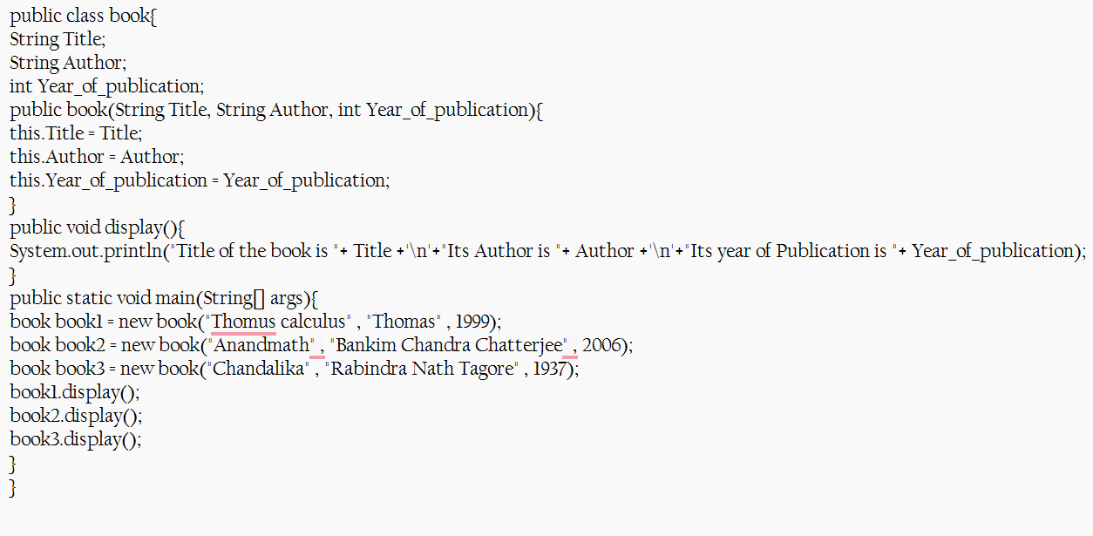

**Output:**

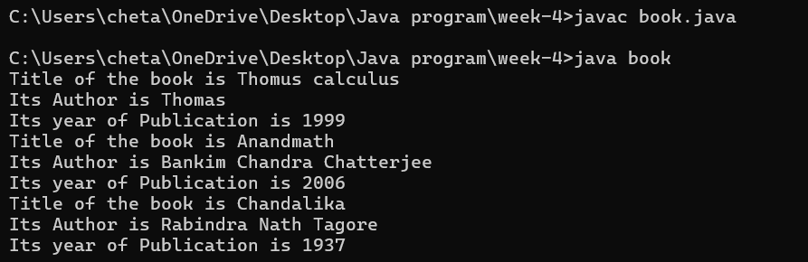

**Errors:**

|  |  |  |  |  |
| --- | --- | --- | --- | --- |
| **Error Type** | |  | | --- | | **Incorrect Code** |  |  | | --- | |  | | **Corrected Code** |
| **Class Name Capitalization** | public class book | public class Book (Java follows PascalCase for class names) |
| **Constructor Name Mismatch** | new book(...) | new Book(...) (Constructor name must match class name) |

**Aim: (ii)** Program to explain the final and the static variables.

**Class Diagram:**

|  |  |  |
| --- | --- | --- |
|  |  |  |
|  |  |  |
|  |  |  |

**Procedure:**

Code:

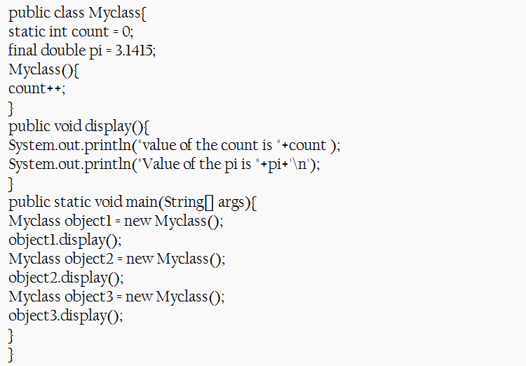

**Output:**

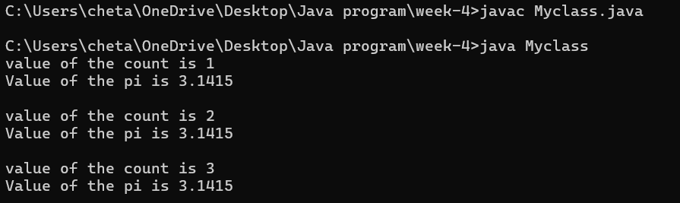

**Error:**

|  |  |  |
| --- | --- | --- |
| **Error Type** | **Incorrect Code** | **Corrected Code** |
| **Attempt to Modify final Variable** | pi = 3.14; (if added inside the constructor or method) | Remove this line (final variables cannot be reassigned) |
| **Incorrect Class Name** | public class Myclass | public class MyClass (Java follows PascalCase for class names) |

|  |  |  |  |
| --- | --- | --- | --- |
|  |  |  |  |
|  |  |  |  |
|  |  |  |  |

**Week-5:**

**Aim:** Create the java program for calculator using multi-level inheritance.

**Class Diagram:**

**Procedure:**

Code:

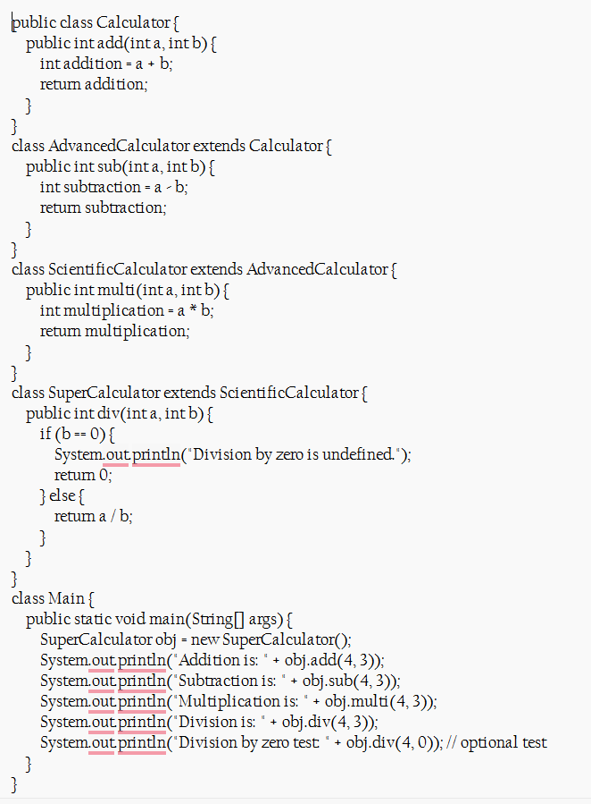

**Output:**

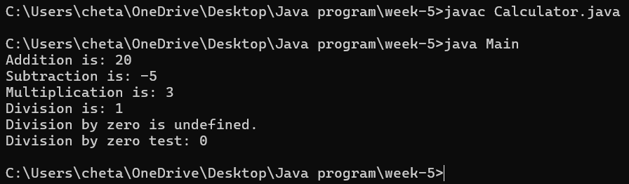

**Error:**

|  |  |  |
| --- | --- | --- |
| **Error Type** | **Incorrect Code** | **Corrected Code** |
| **Invalid file name** | Given calculator as the file name | For public class file should be class name |

**i**

**Aim:** A vehicle rental company wants a system to manage details of vehicles available for rent, including cars, bikes, and trucks. Each vehicle should store basic information such as brand and speed. Cars must include an additional property for the number of doors, while bikes should indicate whether they have gears. The system should also provide a function to display the details of each vehicle and indicate when a vehicle is starting.

**Class Diagram:**

**Procedure:**

Code:

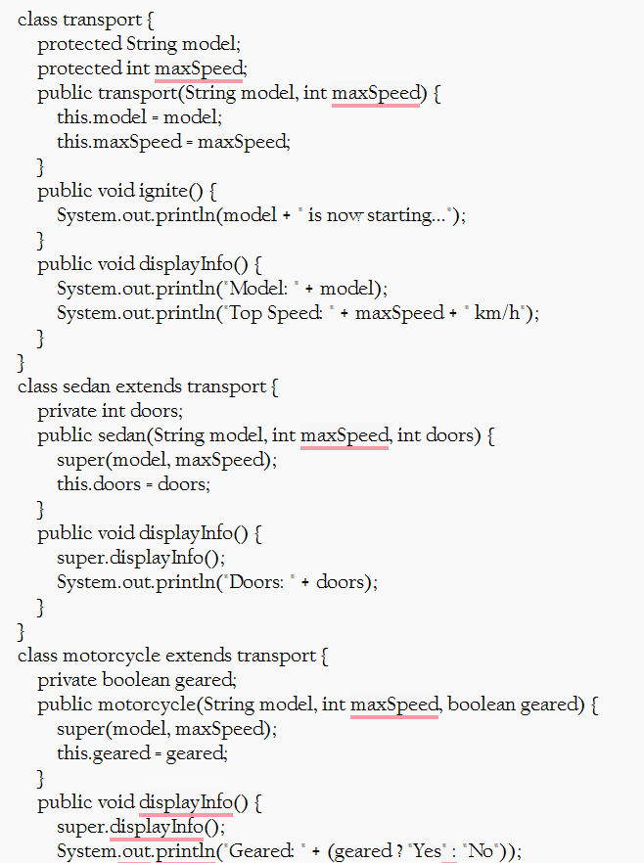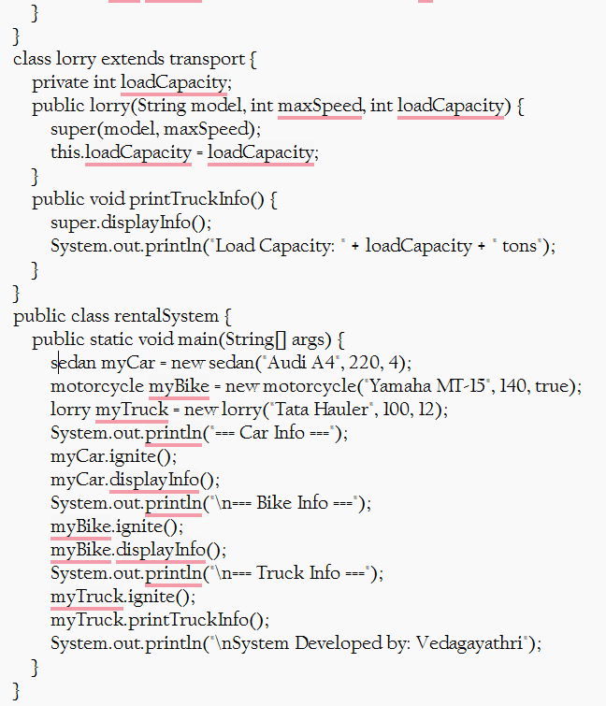

**Output:**

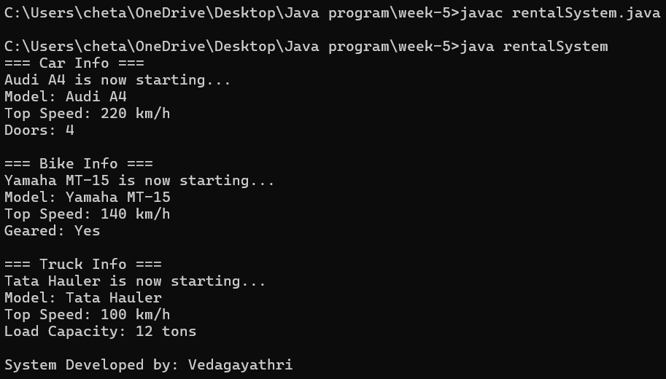

**Error:**

|  |  |  |
| --- | --- | --- |
| **Error Type** | **Incorrect Code** | **Corrected Code** |
| **Syntax Error** | Missing comma between constructor parameters | public Transport(String model, int maxSpeed) |